**Chapter 10: Acid, Bases, and Salts**

**All Lectures Uploaded on YouTube:**

[**https://tinyurl.com/fkm9-chemistry**](https://tinyurl.com/fkm9-chemistry)

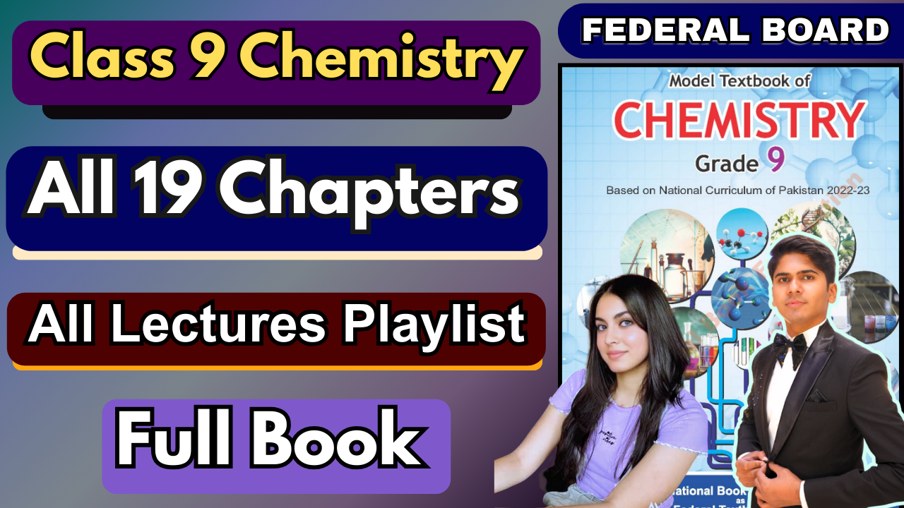

Acids and bases are everywhere! They are in the food we eat (like lemons and apples), the medicines we take (like aspirin and antacids), and the products we use for cleaning.

**10.1. Concept of Acids and Bases**

We can often identify acids and bases by their properties.

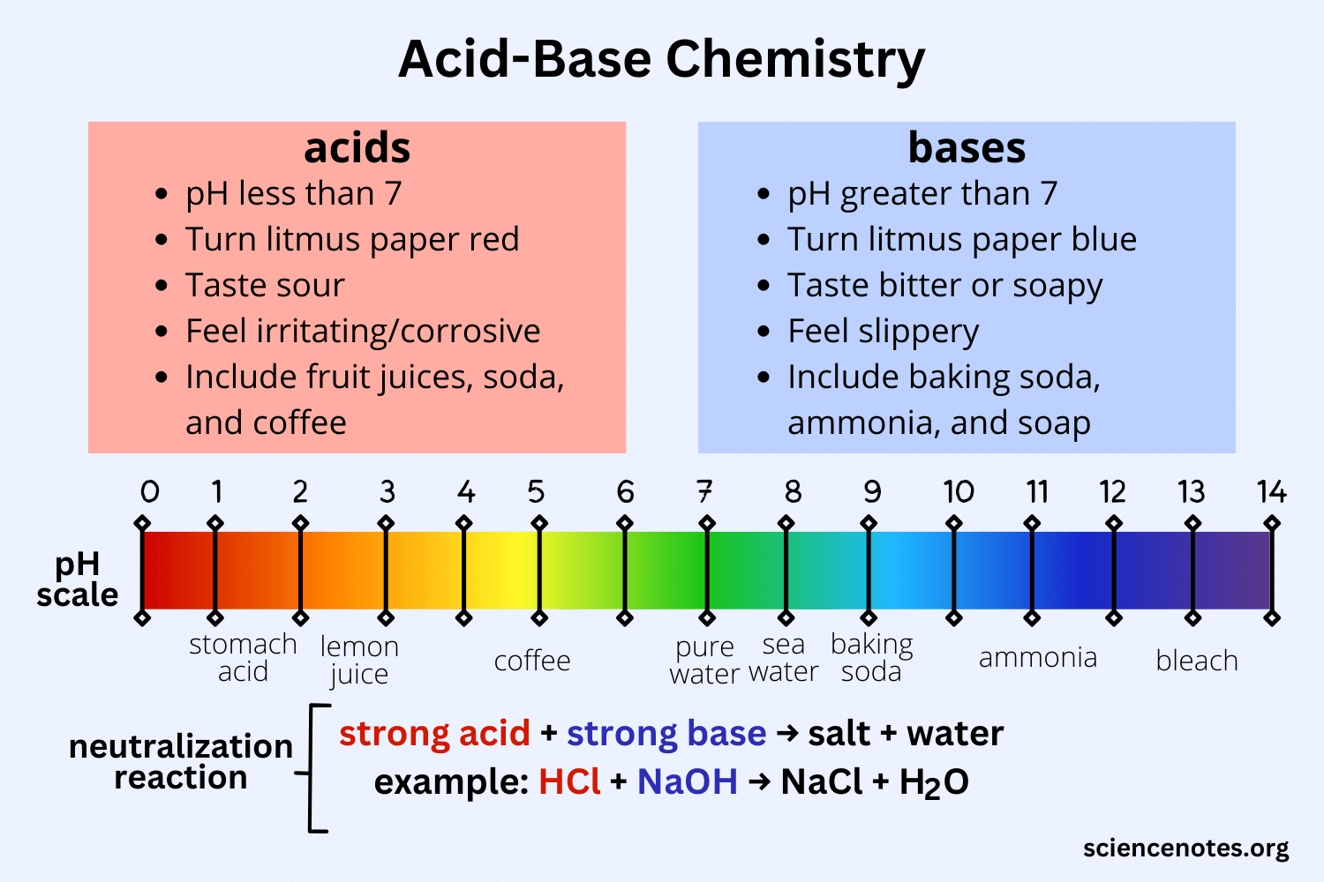

**10.1.1. The Arrhenius Theory (A Simple Scientific Definition)**

In 1887, Svante Arrhenius gave a clear scientific definition:

* An Acid is a substance that, when dissolved in water, produces Hydrogen ions (H⁺).
* A Base is a substance that, when dissolved in water, produces Hydroxide ions (OH⁻).

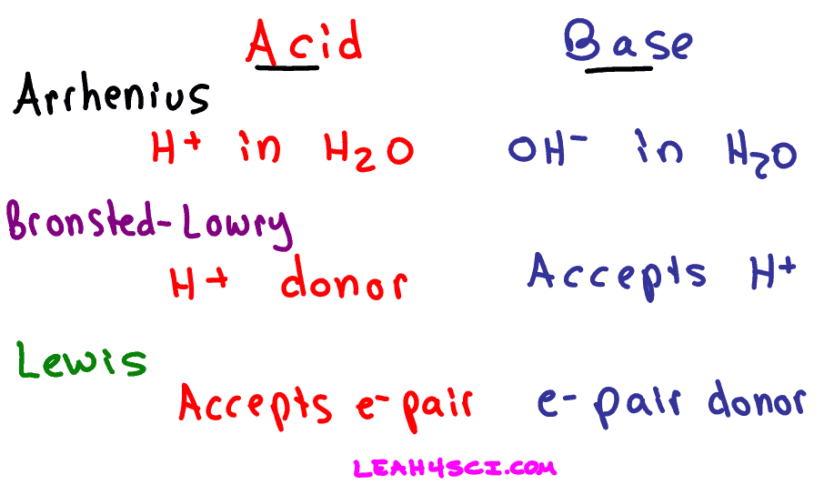

Examples:

∙ Hydrochloric Acid: HCl → H⁺(aq) + Cl⁻(aq) (So, HCl is an acid)

∙ Sodium Hydroxide: NaOH → Na⁺(aq) + OH⁻(aq) (So, NaOH is a base)

**Common Acids and Their Uses:**

| **Name** | **Formula** | **Common Uses** |
| --- | --- | --- |
| Hydrochloric Acid | HCl | Cleaning metals, bricks; removing scale from boilers |
| Nitric Acid | HNO₃ | Making fertilizers and explosives |
| Sulphuric Acid | H₂SO₄ | Making chemicals, drugs, dyes, paints, and explosives |
| Phosphoric Acid | H₃PO₄ | Making fertilizers; used as an acidulant in foods |

**Common Bases and Their Uses**

| **Name** | **Formula** | **Common Uses** |
| --- | --- | --- |
| Sodium Hydroxide | NaOH | Making soap, drain cleaners |
| Potassium Hydroxide | KOH | Making liquid soap, shaving cream |
| Calcium Hydroxide | Ca(OH)₂ | Making mortar, plaster, and cement |
| Magnesium Hydroxide | Mg(OH)₂ | Used in antacids and laxatives |

**Alkalis: A Special Type of Base**

An alkali is a base that is soluble in water. All alkalis are bases, but not all bases are alkalis. Examples of Alkalis (Water-Soluble Bases): KOH (Potassium hydroxide), NaOH (Sodium hydroxide)

Examples of Bases that are NOT Alkalis (Water-Insoluble): Cu(OH)₂ (Copper hydroxide), Al(OH)₃ (Aluminium hydroxide), Fe(OH)₃ (Ferric hydroxide).

**Common Use:** Alkalis are found in many household items like soaps, detergents, shampoos, and toothpaste.

**10.1.2. The Brønsted-Lowry Theory**

The Arrhenius theory couldn't explain why substances like ammonia (NH₃), which has no OH⁻ ions, act as bases. The Brønsted-Lowry theory provides a broader definition.

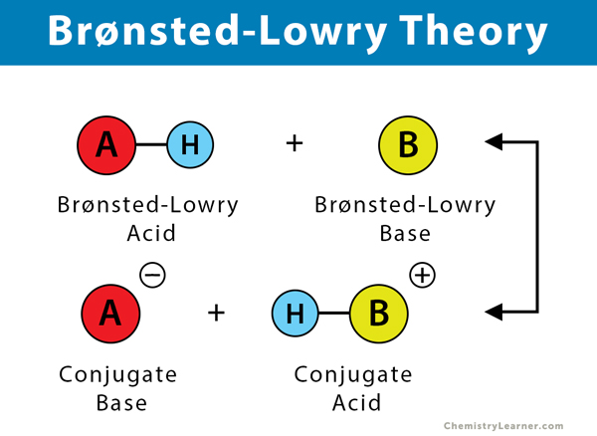

∙ An Acid is a proton (H⁺ ion) donor.

∙ A Base is a proton (H⁺ ion) acceptor.

**How does this work with Ammonia?**

When ammonia gas dissolves in water, it accepts a proton (H⁺) from a water molecule. H₂O + NH₃ → NH₄⁺ + OH⁻

∙ Here, H₂O donates a proton, so it acts as an acid.

∙ NH₃ accepts the proton, so it acts as a base.

**The Special Case of Water: Amphoteric Nature**

∙ In the reaction with HCl, water accepts a proton (acts as a base).

∙ In the reaction with NH₃, water donates a proton (acts as an acid).

∙ A substance that can act as both an acid and a base is called amphoteric. Water is a great example of an amphoteric substance.

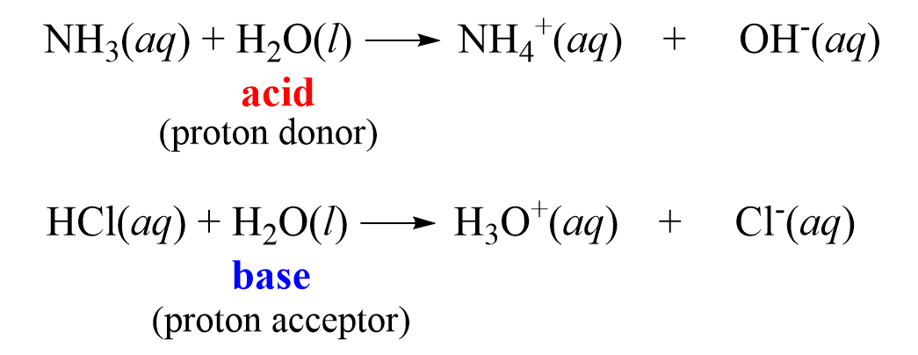

**10.2. Strength of Acids and Bases**

Strength refers to how completely an acid or base ionizes (breaks apart into ions) in water.

**10.2.1. Strong vs. Weak Acids**

| **Property** | **Strong Acids** | **Weak Acids** |
| --- | --- | --- |
| Ionization | Ionize completely (100%) in water. | Ionize only partially in water. |
| Ions Produced | Produce a high concentration of H⁺ ions. | Produce a low concentration of H⁺ ions. |

**Examples (Strong Acids):**

Hydrochloric Acid (HCl), Nitric Acid (HNO₃), Sulphuric Acid (H₂SO₄)

Reaction Examples:

Acetic Acid (CH₃COOH, found in vinegar), Carbonic Acid (H₂CO₃)

∙ Strong Acid: HCl → H⁺(aq) + Cl⁻(aq) (All molecules split into ions)

∙ Weak Acid: CH₃COOH ⇌ H⁺(aq) + CH₃COO⁻(aq) (Only a few molecules split; reaction is reversible)

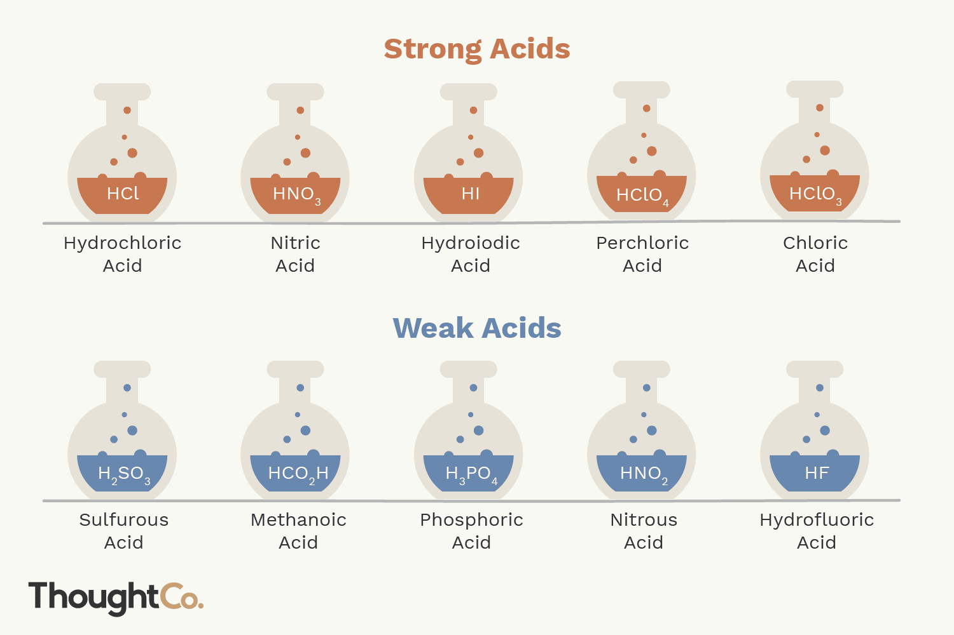

**10.2.2. Strong and Weak Bases**

| **Property** | **Strong Bases** | **Weak Bases** |
| --- | --- | --- |
| Ionization | Ionize completely (100%) in water. | Ionize only partially in water. |
| Ions Produced | Produce a high concentration of OH⁻ ions. | Produce a low concentration of OH⁻ ions. |

Examples:

Sodium Hydroxide (NaOH), Potassium Hydroxide (KOH)Ammonia (NH₃), Aluminium Hydroxide (Al(OH)₃)

Reaction Examples:

∙ Strong Base: NaOH → Na⁺(aq) + OH⁻(aq) (All molecules split into ions)

∙ Weak Base: NH₃ + H₂O ⇌ NH₄⁺(aq) + OH⁻(aq) (Only a small amount of OH⁻ is produced; reaction is reversible)

**10.3. Characteristic Properties of Acids (How Acids Behave)**

Acids have several key chemical reactions:

**1. Reaction with Metals**

Acids react with many common metals (like Zn, Mg, Al) to produce a salt and hydrogen gas (H₂).

You can see bubbles of hydrogen gas being released.

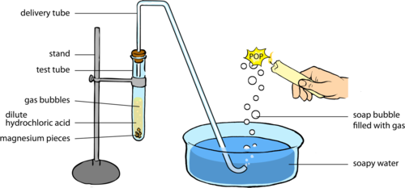

General Equation: Metal + Acid → Salt + Hydrogen

Examples:

o Zn + 2HCl → ZnCl₂ + H₂

o Mg + H₂SO₄ → MgSO₄ + H₂

**2. Reaction with Metal Carbonates**

Acids react with metal carbonates (like washing soda, limestone, marble) to produce salt, water, and carbon dioxide gas (CO₂). The CO₂ gas causes fizzing or bubbling. 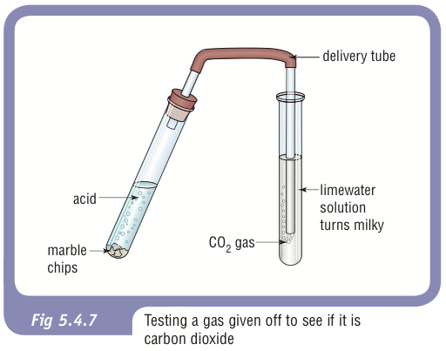

General Equation: Metal Carbonate + Acid → Salt + Water + Carbon Dioxide

Examples:

o Na₂CO₃ + 2HCl → 2NaCl + H₂O + CO₂

o CaCO₃ + H₂SO₄ → CaSO₄ + H₂O + CO₂

Use: This reaction is used in industries to make glass, paper, and soap.

**3. Neutralization Reaction with Bases**

This is a fundamental reaction where an acid and a base cancel each other out, producing salt and water.

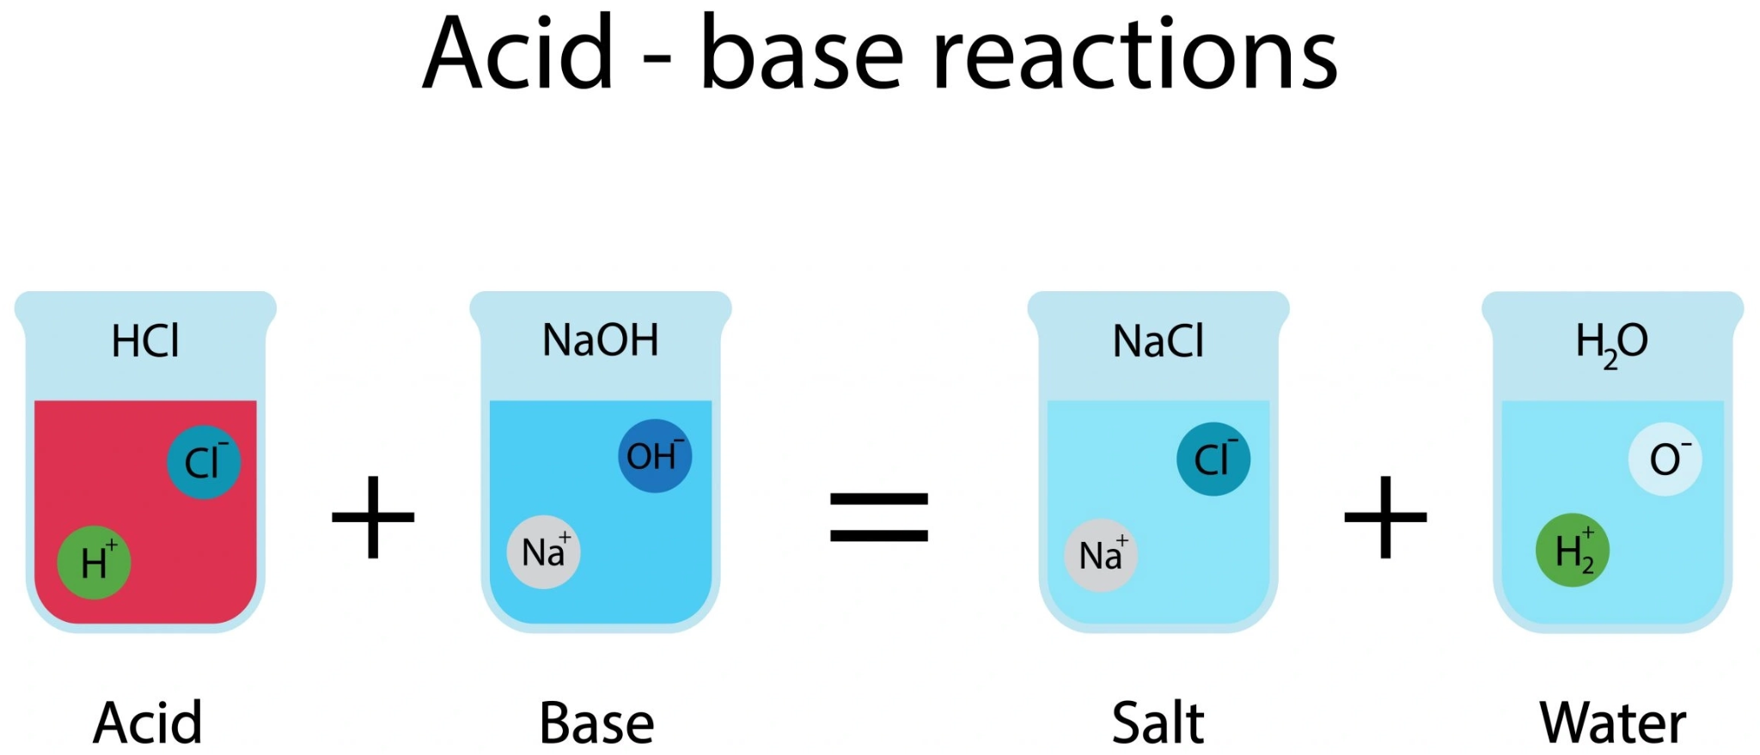

General Equation: Acid + Base → Salt + Water

Examples:

o HCl + NaOH → NaCl + H₂O

o H₂SO₄ + 2KOH → K₂SO₄ + 2H₂O

**Real-World Impact:** Acid Rain

Normal rain is slightly acidic due to dissolved CO₂.Acid rain is formed when pollutants like sulfur and nitrogen oxides dissolve in rainwater, creating sulfuric and nitric acids.Because acids react with carbonates and metals, acid rain corrodes buildings, statues (especially marble, which is CaCO₃), and metal structures.

**10.4. Characteristic Properties of Bases (How Bases Behave)**

**1. Neutralization Reaction with Acids**

As shown above, this is the primary reaction of a base with an acid.

General Equation:

Base + Acid → Salt + Water

**2. Reaction with Ammonium Salts**

When a base is heated with an ammonium salt, it produces a salt, ammonia gas (NH₃), and water. Ammonia gas has a strong, pungent smell.

General Equation: Base + Ammonium Salt → Salt + Ammonia + Water Examples:

o NaOH + NH₄Cl → NaCl + NH₃ + H₂O

o KOH + NH₄Cl → KCl + NH₃ + H₂O

**10.5. Oxides and Hydroxides**

**Formation of Metal Oxides**

Metals react with oxygen in the air to form metal oxides.

Examples:

o 4Na + O₂ → 2Na₂O (Sodium Oxide)

o 2Mg + O₂ → 2MgO (Magnesium Oxide)

**Metal Oxides are Basic**

Most metal oxides are basic in nature. When they dissolve in water, they form metal hydroxides (alkalis).

How it works: The oxide ion (O²⁻) from the metal oxide is unstable in water. It acts as a base (a proton acceptor) and takes a proton (H⁺) from a water molecule, forming two hydroxide ions (OH⁻).

General Equation: Metal Oxide + Water → Metal Hydroxide

Examples:

o MgO + H₂O → Mg(OH)₂

o Na₂O + H₂O → 2NaOH

o CaO + H₂O → Ca(OH)₂

Most metal oxides/hydroxides are basic, but a special few can react with both acids and bases. These are called amphoteric oxides/hydroxides.

Examples: Aluminium Oxide (Al₂O₃), Aluminium Hydroxide (Al(OH)₃), Zinc Oxide (ZnO), Zinc Hydroxide (Zn(OH)₂).

* Acids are characterized by their reactions with metals (producing H₂), carbonates (producing CO₂), and bases (neutralization).
* Bases neutralize acids and can release ammonia gas when heated with ammonium salts.
* Metal Oxides are generally basic and form metal hydroxides (alkalis) in water.
* A few metal oxides/hydroxides are amphoteric, meaning they can behave as either an acid or a base.

